**“Lie Detection Using Micro-Facial Expression”**

A MAJOR PROJECT REPORT SUBMITTED TO

**RAJKIYA ENGINEERING COLLEGE BANDA**

(An Affiliated Institute of Dr. A.P.J Abdul Kalam Technical University, Lucknow UP)

In partial fulfilment of the requirements for Major Project, seventh semester

**Bachelor of Technology**

**In**

**Information Technology, REC BANDA**

*Submitted by*

**Utsav Singh (1773413054)**

**Somendra Shekhar (1773413046)**

**Shubham Kumar (1773413044)**

**Hemant Gaur (1773413016)**

Under the Guidance of

**Dr. Vibhash Yadav**

Associate Professor

Dept. of IT

REC Banda – 210201

**DEPARTMENT OF INFORMATION TECHNOLOGY**

**RAJKIYA ENGINEERING COLLEGE BANDA**

2020-2021

**Declaration**

I hereby declare that the project report entitled “**Lie Detection Using Micro-Facial Expression**” submitted by us to Rajkiya Engineering College, Banda is the requirement for the award of the degree of the B. Tech in Information Technology is a record of bonafide project work carried out by us under the guidance of Dr. Vibhash Yadav Sir. I further declare that the work reported in this project has not been submitted and will not be submitted either in part or in full for the award of any other degree in this institute.

Date: Signature of the Candidates:

**Rajkiya Engineering College Banda**

**Department of Information Technology**

**CERTIFICATE**

This is to certify that the Project entitled “**Lie Detection Using Micro-Facial Expression**” which is submitted by **Utsav Singh, Somendra Shekhar, Shubham Kumar, Hemant** **Gaur** is a record of bonafide work carried out by them, in the fulfillment with Degree of Bachelor of Technology Information Technology, Rajkiya Engineering College, Banda. This work is done during year September’20 to March’21, under our guidance.

Date: 18/03/2021

**Internal Guide Professor:**

Dr. Vibhash Yadav

Associate Professor

**Acknowledgement**

We would like to express our special thanks & gratitude to our guide and Head of Department of Information Technology “Dr. Vibhash Yadav Sir” for their valuable guidance and support in completing my project.

We would also like to extend our gratitude to our Honorable Director “Prof. S.P. Shukla Sir” for providing me with all the facility that was required.

We also do not like to miss the opportunity to acknowledge the contribution of all faculty members of the department for their kind assistance and cooperation during the development of our project. Last but not the least, we acknowledge our friends for their contribution in the partial completion of the project.

Utsav Singh

Somendra Shekhar

Shubham Kumar

Hemant Gaur

**TABLE OF CONTENTS**

**CONTENTS**

1. Objectives
2. Introduction
   1. Background of topic
   2. Organization of report
3. Literature survey
   1. Introduction
   2. Description of previous work
   3. Comparison of previous papers
   4. Background of previous work
   5. Problem Definition
   6. Technical novelty / Scope of work
4. Proposed technique
   1. About work
   2. Algorithm
   3. Flow diagram
5. Implementation and Result
   1. Introduction
   2. Simulation or implementation tool details
   3. Include some important code and front end snapshots
   4. Result and outcomes
6. Conclusion and future direction
7. References

**1.Objectives:**

The main objective is to detect the 6 universal and primary emotions based on micro expressions of a subject under test, which is thereby useful in the process of detecting lies. Another salient feature is to detect the pulse rate of the subject under test. This additional feature of detecting pulse of a subject brings authenticity to the study. Wherein emotions, based on micro expressions and pulse rate, can be observed at any given instance. Results from these emotions and pulse rates are to be exhibited in a Graphical User Interface (GUI). GUI accommodates videos and their corresponding graphs. This study cannot be called as a lie-detector, since, it does not explicitly detect any lies, but it extracts an emotion which would be helpful in the process of lie detection.

**2.Introduction:**

Lie detection, in general, is referred to as a polygraph. A polygraph is a device that measures various parameters such as respiration, blood pressure, pulse and sweat which are used as indices in estimating a lie. The drawback of the polygraph is that it triggers false positives when the subject under test is anxious or emotionally aroused. A new design is being created where emotions play a crucial role in determining the lies and overcoming the difficulties posed by the traditional polygraph. Also, the traditional lie detection techniques rely on wired system which induces panic in the subject under test. This new study is designed to overcome the drawbacks of the traditional polygraph and to help the investigator in the process of detecting lies by not involving any physical contact with the subject under test.

Emotions play a very prominent and purposeful role in day-to-day life. Emotions directly reveal the exact feelings of a person at any given time. This new study also works as a tool for deciphering a person’s present emotional state around with ease. A technique, where emotions play a crucial role in the process of detecting lies, is more reliable as emotions are universal. At any instance of time, the emotion felt by a person can only be deciphered through the expression put up by that person.

A major class of expressions are categorized into 6 basic emotions such as anger, disgust, fear, happy, surprise, sadness, and contempt. Contempt is an emotion which has been recently added to the list of universal emotions. In general, few predominant emotions such as fear, anger and sadness are mostly observed in the process of lie detection. Thus, this new study helps the investigators, in deciphering the true feelings of subject under test, and to common people, as a tool for understanding other people and their feelings easily.

When a subject under test is at a high-stake situation, there would be a leakage of expression, involuntarily. Thus, high stake situations provide more probability in estimating the emotion correctly. Micro expressions occurring at high stake situations are the basis for these kinds of involuntary emotions. Micro expressions occur in a fraction of a second and are hard to recognize in real time without good expertise. Emotions in conjunction with micro expressions play a crucial role in the process of detecting lies. Generally, when a person tries to hide the truth, he feels the pressure inside, which indeed increases his heart rate. Thereby, measuring the heart rates while questioning the subject would strengthen the emotion predictions. This study does both of them simultaneously without any physical contact.

**3. Literature Survey:**

**3.1 Introduction:**

Literature refers to a collection of published information/materials on a particular area of research or topic, such as books and journal articles of academic value. It should include the key sources related to the main debates, trends and gaps in your research area. Generally, the process of recognizing normal facial expressions involves preprocessing, feature extraction and classification. Micro-expression recognition is not an exception, but the features extracted should be more descriptive due to the small movement in micro-expressions compared with normal expressions.

**3.2Description of previous work:**

**1.** “A Review on Facial Micro-Expressions Analysis Datasets, Features and Metrics” is proposed by Walied Merghani, Adrian K. Davison, Member, IEEE, Moi Hoon Yap in 2018 year . Different dataset used in paper are: Polikovsky USF-HD, CASME dataset . One of the first micro-expression datasets was created by Polikovskyet al.

This research paper was based on Spontaneous dataset and earlier research paper was based on non- spontaneous dataset .

Developing micro-expression spontaneous datasets is one of the biggest challenges faced in this research area. It is difficult to elicit micro expressions because they are difficult to fake, so we need to get the true emotion while the person try to hide it. Some spontaneous datasets to date include: SMIC , CASME , CASME II , SAMM and CAS(ME)2 . SAMM was designed for micro-movements with less emphasis on the emotional side for increased objectiveness. Available datasets will be described in this section.

**2.** “Micro-Expression Extraction For Lie DetectionUsing Eulerian Video (Motion and Color) Magnification” proposed byGautam Krishna , Chavali Sai Kumar N V , Bhavaraju Tushal , Adusumilli Venu Gopal , Puripanda in 2014 year . Dataset used in paper are: Cohn-Kanade image database, ExtendedCohn-Kanade image database.

In the year 2000 an image database, with 486 sequences of facial expression images from various subjects have been collected to create this database and is popularlyknown as Cohn-Kanade database. Initially, Cohn-Kanade image database is designed only for facial expression analysis and these expressions are classified using a method called FACS . FACS coding is verified manually, which makes the database quite reliable. This image database includes samples from various backgrounds, sex, varying skin color and people with eyeglasses . The disadvantage with this database is thatemotion labels are not specified, which means, FACS are to be used manually to codethese emotion labels.

Later, in the year 2010, an extended image database has been introduced to overcome few drawbacks of the original. In extended database, another 107 sequences across 26 subjects have been added to the original image database . Thus, the extended database contains a total of 593 sequences across 123 subjects . The extended image database also has emotion labels.

**3.** “Objective Classes for Micro-Facial Expression Recognition” proposed by Adrian K. Davison , Walied Merghani and Moi Hoon Yap in 2018.

Different algorithm used in paper are : (Histogram of Oriented Gradient) HOG , (Histograms of Oriented Optical Flow)HOOF, (Local Binary Patterns)LBP.

HOG features are a set of appearance features. HOG features give normalized gradient information that is extracted locally in an image . HOG feature extraction involves, dividing the image matrix into cellin sand then applying gradient kernels to extract the gradients. Numerous gradients are taken into account to find the overall appearance of the micro expression.

**4.** “Lie Detection based on Facial Micro Expression,Body Language and Speech Analysis” Proposed by Soumya Barathi C in 2016 year. Albert Mehrabian, the author of silent messages, says that only 7% of communication is verbal and the 93% is non verbal(55% being body language,38% tone of voice). Paul Ekman[2], a pre-eminent psychologist, put forth the theory of universality of facial expressions which states that facial expressions are unlearned behaviors that develop independently from cultured expressions. Studies show that congenitally blind people make the same expressions even though they have never seen other people’s faces.

### 3.3 Comparison Of Previous Paper:

|  |  |  |  |  |
| --- | --- | --- | --- | --- |
| Authors | Dataset | Lie detection micro facial expression algorithm | Accuracy | Year of publication |
| Walied Merghani, Adrian K. Davison, Member, IEEE, Moi Hoon Yap[1] | SMIC ,CASME | HOOF ,HOG , LBP | 70% | 2018 |
| Gautam Krishna , Chavali Sai Kumar N V, Bhavaraju Tushal , Adusumilli Venu Gopal , Puripanda[2] | Cohn-Kanade image database, ExtendedCohn-Kanade image database. | HOG (Histogram of Oriented Gradient) | 54% | 2014 |
| Adrian K. Davison, Walied Merghani and Moi Hoon Yap [3] | CASME II and SAMM | HOOF , HOG 3D, HOG | 86% | 2018 |
| Soumya Barathi C[4] | SURF(Speeded Up Robust Features) approach | K-Means algorithm | 82% | 2016 |

**3.4 Background of previous paper:**

All the till date published papers contains the performance of different algorithms. Models were trained using the different machine learning algorithms. In previous papers focus was given on calculating the accuracy of different algorithms. After analyzing the previous work most research paper support HOG , EVM as good algorithm for training the model. Many measuring parameters like accuracy, performance and recall value were calculated to compare the different dataset. Value of accuracy was given due importance for comparison purpose.

**3.5 Problem Definition:**

1. How to find the subtle changes in micro expressions of a subject under test froma video using motion magnification of EVM?

2. How to recognize the 6 universal and primary emotions (with neutral expressions) based on micro expressions using Back-propagation Neural Network (NN) from a motion magnified video?

3. How to find the pulse rate of a subject under test from a video using color magnification of EVM?

4. How to create a GUI that accommodates and exhibits all the results?

**3.6 Technical Novelty:**

This study works only for videos taken in one-to-one interview set-up and has few constraints, like a stable platform with no external jerks or disturbances involved. This study can be made available for all the conditions of videos.

This study mainly helps in the process of lie detection. This study can be made handy, when voice analysis is done with video analysis. When the facial cues and vocal cues are combined the accuracy of finding a lie raised to the highest bar After the addition of voice pitch recognition and analysis, the present study can be called as a lie detector.

**4.Proposed technique:**

**4.1About Work:**

The proposed model consist of the facial micro expression detection using EVM (Eulerian Video Magnification). Micro-expressions go unnoticed due to its involuntary nature, but EVM is used to magnify them and makes them noticeable.

**4.2 Algorithm:**

EVM and Voila Jones algorithm have been used to implement the task.

**4.2.1 EVM**

EVM (Eulerian Video Magnification, Euler Video Magnification or Euler Image Magnification) is an algorithm that amplifies small changes in the video. We can turn small changes in the video into changes that can be observed with the naked eye. This algorithm can be used to extract heart rate information from videos, and it can also amplify small movement changes in videos.

The methodology of EVM is shown below in the figure 1.1: 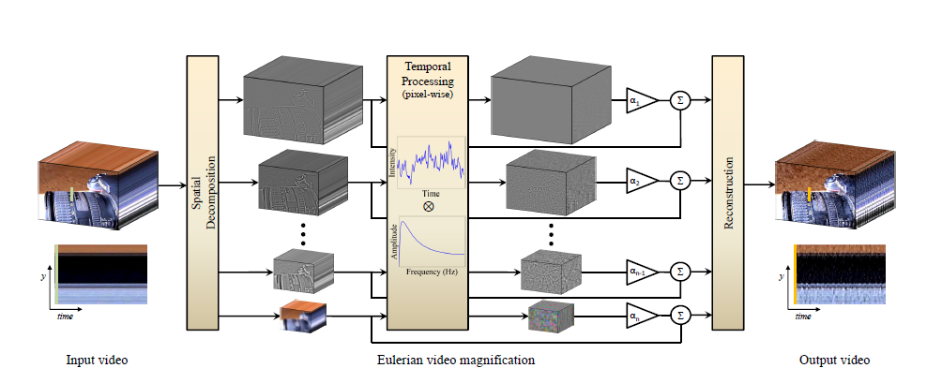

***Figure 1.1:*** Methodology of EVM

**Video specifications and prerequisites of EVM:**

The video specifications considered in the EVM are

1. The size of the video frame is 640x480.

2. The frame rate for videos are 30 FPS.

3. The videos are considered either in ‘.avi’ or ‘.mp4’ formats.

4. The videos to be analyzed are recorded in standard one-to-one interview setup format.

**Spatial Decomposition:**

It is to downsample each frame in the video to form an image pyramid. There are two components of the image pyramid here, one is the Gaussian pyramid, and the other is the Laplacian pyramid. The Gaussian Pyramid is often used to amplify colors, while the Laplacian Pyramid is used to amplify movement.

**Temporal filter:**

Video can be seen as a continuous picture. From the perspective of a single pixel in the picture, the change of each pixel in the video can be seen as a time domain signal. The information about the movement of the object is hidden in the change of a single pixel. The method used in the thesis is bandpass filter, ideal bandpass filter is used when zooming in color, IIR filter is used when zooming in motion, and Butterworth filter is mainly used in the thesis.

**Reconstruction:**

The last step of the process is to restore the pictures decomposed into image pyramids. In this paper, the restoration method of the Gaussian pyramid is to up sample the lowest level of the Gaussian pyramid (the one with the smallest picture) and then superimpose it on the original image. In this implementation, the pixel value of the final picture will exceed 255 and overflow occurs. What needs to be done at this time is to normalize the pixel value to between 0-255. For the Laplacian Pyramid, the lowest level of the pyramid is up-sampled, then the upper level is superimposed, and so on, and finally superimposed with the original image.

**4.3 Flow Diagram:**

HOG feature

extraction

Color Magnification Video

Color Magnification

Graph Writer

Pulse Graph

Graph Writer

Voila Jones

Emotion Graph

Motion Magnification

GUI

Graph Writer

Voila Jones

Input

video

EVM

Motion Magnification Video

Color Magnification Video

YCbCr

Conversion

**5. Implementation and Result:**

**5.1 Introduction:**

Micro expressions are hard to identify and so it is almost impossible for an average person to detect and decipher micro expressions because of its impulsive nature. But more recently, a design called Eulerian Video Magnification (EVM) has been proposed, which can be used for observing these micro expressions. EVM magnifies small and subtle motion that is captured in a video, which are generally impossible to identify with naked eyes. EVM uses the method of spatial decomposition on input video and then temporal filtering is applied to each and every decomposed frame of the video. EVM technique not only magnifies small and subtle motions, but when the decomposition method and the filters are changed, it also magnifies the colour intensity variations. Motion magnification is used to magnify the subtle changes occurring in the face. EVM uses the method of spatial decomposition on input video and then temporal filtering is applied to each and every decomposed frame of the video. EVM technique not only magnifies small and subtle motions, but when the decomposition method and the filters are changed, it also magnifies the colour intensity variations. Motion magnification is used to magnify the subtle changes occurring in the face. Colour magnification is used to magnify the colour changes in the face, which helps in finding the pulse rate of the subject under test.

**5.2 Simulation or implementation tool details:**

A GUI library Tkinter is going to be used to show the final result of all the process.

Tkinter is the standard GUI library for Python.

Machine Learning library – OpenCV, NumPy, SciPy will be used.

OpenCV (Open Source Computer Vision library) is a library of programming function mainly aimed at real time computer vision.

NumPy, which stands for numerical Python, is a library consisting of multidimensional array objects and a collection of routines for processing those arrays.

SciPy is an open source python library which is used to solve scientific and mathematical problems. It is built on NumPy extension.

**5.3 Result and outcomes:**

**Result of motion magnification through EVM:**

The motion magnified video frame is shown below in the figure 2.1:

 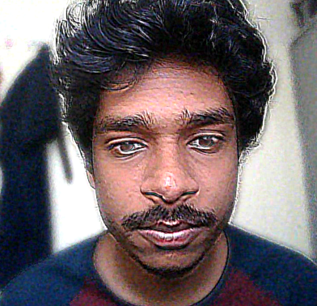

**Result of color magnification through EVM:**

The color magnified video frame is shown below in the figure 2.2:

 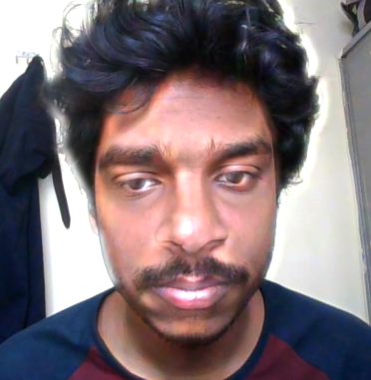

**6. Conclusion and future direction:**

This study is not an explicit lie detector, but it extracts micro expressions, which in turn helps both people and investigators in the process of detecting lies. Micro expressions reveal the true intentions of the subject/people. Observing, analyzing and understanding these micro expressions can thus intensify the process of detecting a lie, but comprehending such impulsive expressions is tedious and tough task for an average person. In general, a physical contact with a subject under test can induce a sense of consciousness in that person. Using Eulerian video magnification emotion through motion magnification and pulse through color magnification is extracted without any physical contact with the subject under test. The main advantage of no physical contact would result in an unconscious emotion leakage which is captured and deciphered. When both motion and color magnification are considered, it helps an investigator of lies in the process of finding the truth from the subject under test.

**Future direction:**

1.Contempt can be added into the list of emotions.

2.This study can include voice analysis with video analysis.

3.This requires a pre-recorded video to work. If this could give a result in real-time the accuracy of finding a lie raised to the highest bar.

1. **References:**

**[1]** Walied Merghani, Adrian K. Davison, Moi Hoon Yap, “A Review on Facial Micro-Expressions Analysis Datasets, Features and Metrics” in IEEE 2018.

**[2]** Gautam Krishna, Chavali Sai Kumar N V, Bhavaraju Tushal, Adusumilli Venu Gopal, Puripanda, “Micro-Expression Extraction For Lie DetectionUsing Eulerian Video (Motion and Color) Magnification” in 2014.

**[3]** Adrian K. Davison, Walied Merghani and Moi Hoon Yap, “Objective Classes for Micro-Facial Expression Recognition” in 2018.

[4] Soumya Barathi C, “Lie Detection based on Facial Micro Expression,Body Language and Speech Analysis” in 2016.